

Azure Data Service Fundamentals

Microsoft azure government (MAG) edition v.9

Scott Larson, Binh Cao | Azure Data Service Fundamentals | 11/29/2016

# Introduction

## Goal of this Course

This is a foundational, 101 level introductory course to using data services in the Azure Cloud platform. Some basic knowledge of Microsoft Azure is helpful but not required.

The goal of this course is to familiarize a technical audience, particularly database administrators and developers, on how to build, deploy, and manage relational databases in the Azure environment.

## Use of this training material

This training material and workbook has been created for the sole use of Microsoft customers only. Customers are allowed to re-use the material to deliver the same training to other internal users (Train-the-trainer model). Microsoft does not grant the customer or any trainer commercial rights to resell, republish, or deliver this training as part of a paid engagement.

The information provided in this material is strictly for training purposes only. Microsoft makes no warranties to the accuracy and is not responsible for any unforeseen damages caused in the event that the examples in this workbook are used in a production environment. If uncertain, please always consult Microsoft Consulting Services or Microsoft Certified Partners whenever you are deploying services and solutions in a production environment. The information and examples in the material does not grant the user any licensing rights.

Due to the rapid and fluid nature of the Microsoft Azure Cloud platform, the contents of this workbook may be different at the time of writing than compared to when the course based on the material is delivered. If you notice discrepancies, please help us keep the content up to date by providing feedback to your Microsoft Account Team.

©Copyright 2016 Microsoft Corporation.

# Create A Resource Group

References:

* [*https://docs.microsoft.com/en-us/azure/azure-resource-manager/resource-group-overview*](https://docs.microsoft.com/en-us/azure/azure-resource-manager/resource-group-overview)

1. Click on Resource Groups on left menu, Click Add
2. Name the Resource Group, select a subscription, and resource group location  
   Machine generated alternative text:
   Microsoft Azure 
   Resource groups 
   Resource groups 
   + Add 
   Columns Refre h 
   I Of 3 
   — Dont see a subscription? Switch &rectories 
   (0) 
   Resource groups 
   All resources 
   SQL databases 
   App Services 
   Virtual machines (classic) 
   Virtual machines 
   Cloud services (classic) 
   Subscriptions 
   SQL servers 
   Filter name. 
   19 items 
   Defau Mach ineLearN US 
   0) 
   Defau It- 
   Default-su-centraus 
   0) 
   Default-su-Wesws 
   Default-storage-SouthCentraIUS 
   0) 
   Default-storage-WestUS 
   lapddemo 
   CO) LarsonAD 
   Microsoft Azure Internal Consumption 

# Create an Azure Virtual Machine SQL Server 2016 SP1 Gallery Image

Task:

* Create a Virtual Machine from a “Gallery Image”. This image will have SQL Server 2016 SP1 already installed.

1. Select the Virtual Machines Option from the left menu (NOT “Classic”), Click AddMachine generated alternative text:
   v Page v Safety v 
   Microsoft Azure 
   Virtual machines 
   Virtual machines 
   + Add 
   Columns Refresh 
   Tools v 
   I of 3 a subscription? Switch &rectories 
   (0) 
   Resource groups 
   All resources 
   SQL databases 
   App Services 
   Virtual machines (classic) 
   Virtual machines 
   Cloud services (classic) 
   Subscriptions 
   SQL servers 
   ta factories 
   Storage accounts (class.„ 
   Filter name. 
   8 iterns 
   LarsonAD 
   Larson DS 
   LarsonR 
   LarsonSQL2016 
   LarsonSQL2016ss 
   LarsonSSAS 
   Microsoft Azure Internal Consumption 
   STATUS 
   located) 
   located) 
   located) 
   located) 
   located) 
   located) 
   located) 
   located) 
2. In the “Basics” Section, fill in the fields…for Resource Group, select “Use Existing” and Select the Resource Group you created in the previous sectionMicrosoft Azure 
   Virtual machines 
   > Compute 
   SQL Server 2016 SP1 Enterprise on Windows Server 2016 > 
   Basics 
   Mame 
   disk type 
   l_lser narne 
   assword 
   •ρήοη 
   MicToson Azure lntMn1 Cmslmpton 
   Create virtual 
   Create virtual machine 
   Resource groups 
   ΑΙΙ resources 
   Recent 
   SQL databases 
   Αρρ Services 
   Wlrtual machines @assic) 
   Wlrtual machines 
   CIoud services (classic) 
   SubscrEtions 
   SQL servers 
   Data tactories 
   Storage accounts (class.„ 
   Wlrtual networks (classic) 
   Azure Active Directory 
   1 
   2 
   3 
   4 
   5 
   Conhgure basic 
   Choose virtual m"nine size 
   Settings 
   Conhgure featues 
   SQL Sever settings 
   Conhgure server settings 
   Sumrnary 
   sever 2016 sp1 Enter'm-ise„. 
   Resource ςτοι_ιρ 
   • Create O l_Ee existi ης 
   LarsMTMlPRG 
3. Select 2- Size, Browse the various options and note the # of cores and Memory. These are simply virtual machines hosted in the Microsoft Cloud. Select A6.  
   Microsoft Azure 
   Virtual machines 
   > Compute 
   SQL Server 2D1 6 SPI Enterprise on Windows Server 2016 
   C 「 eate Virtual machine 
   Create virtual 
   machine 
   Choose a Size 
   十 
   1 
   MulOPS 
   Resource groups 
   十 
   十 
   balancng 
   Load balawng 
   balancng 
   All 50u es 
   ~ 〕 Ⅵ u m n SIZe 
   SQL databases 
   133.92 
   267.84 
   535.68 
   3 4 5 
   AppServices 
   Settings 
   」 3 ONTH ESTIMATED) 
   USD/MONTH (ESTIMATED) 
   」 3 ONTH ESTIMATED) 
   Configu 「 eoptionalfeatu 「 
   \"rtualmachines(classic) 
   Standa 
   A6 Standa 
   Al Stand 
   2 
   4 
   8 
   Cores 
   Ⅵ u machines 
   SQL 5 「 「 settings 
   14 
   28 
   56 
   GB 
   G3 
   GB 
   Configu 「 eSQ—serversettings 
   Cloud services (Classic) 
   Datadisks 
   Datadisks 
   Su 「 
   Subscriptlons 
   'OPS 
   MulOPS 
   SQLSever2016SPIEnterpriE„. 
   十 
   balancng 
   Load balawng 
   balancng 
   芞 
   SQL servers 
   Data factories 
   Storage accounts (Class. 
   245.52 
   491.04 
   982.08 
   Ⅵ u networks (classic) 
   us 3NTH ESTIMATED) 
   USD/MONTH (ESTIMATED) 
   us 3NTH ESTIMATED) 
   Azure Active Directory 
   Standar 
   A9 Standard 
   杺 Standar 
   8 
   16 
   8 
   Cores 
   Monitor 
   56 
   112 
   56 
   GB 
   G3 
   GB 
   u 丨 center 
   Da d 
   Da d 
4. Select *3- Settings* For purposes of this lab, accept the default settings.

Machine generated alternative text:
Microsoft Azure 
Virtual machines 
> Compute 
Create virtual machine 
(0) 
Resource groups 
All resources 
Recent 
SQL databases 
App Services 
Virtual machines (classic) 
Virtual machines 
Cloud services (classic) 
Subscriptions 
SQL servers 
Data factories 
Storage accounts (class.„ 
Virtual networks (classic) 
Azure Active Directory 
Monitor 
Security Center 
Billing 
1 
3 
4 
5 
SQL Server 2016 SPI Enterprise on Windows Server 2016 > 
SQL Server settings 
SQL connectivib'@ 
Private (within Virtual Networß 
1433 
SQL Authentication 
Enable 
Create virtual machine > SQL Server settings > Storage 
X Storage configuration 
Et size. 
to m." virtual 
Storage size 
I data disks MI be to the virtual machine. 
This value was computed on the value of 
IOPS, thrmjghput, ard storage size. 
Storage optimization • 
Setbngs 
SQL Server setbngs 
Configure server settings 
Summary 
SQL sever 2016 SPI Enterprise„. 
Storage configurabon 
General 
Autc-nated patching 
Sunday at 2:00 
Autc-nated backup • 
Disabled 
Azure Key Vault 
Disabled 
R Services (Advanced analytics) 
Enable 

1. Select *4- SQL Server Settings* For purposes of this lab. Note the options and accept the defaults, Click Summary=>Create

Machine generated alternative text:
Microsoft Azure 
Virtual machines 
> Compute 
Create virtual machine 
(0) 
Resource groups 
All resources 
Recent 
SQL databases 
App Services 
Virtual machines (classic) 
Virtual machines 
Cloud services (classic) 
Subscriptions 
SQL servers 
Data factories 
Storage accounts (class.„ 
Virtual networks (classic) 
Azure Active Directory 
Monitor 
Security Center 
Billing 
1 
3 
4 
5 
SQL Server 2016 SPI Enterprise on Windows Server 2016 > 
SQL Server settings 
SQL connectivib'@ 
Private (within Virtual Networß 
1433 
SQL Authentication 
Enable 
Create virtual machine > SQL Server settings > Storage 
X Storage configuration 
Et size. 
to m." virtual 
Storage size 
I data disks MI be to the virtual machine. 
This value was computed on the value of 
IOPS, thrmjghput, ard storage size. 
Storage optimization • 
Setbngs 
SQL Server setbngs 
Configure server settings 
Summary 
SQL sever 2016 SPI Enterprise„. 
Storage configurabon 
General 
Autc-nated patching 
Sunday at 2:00 
Autc-nated backup • 
Disabled 
Azure Key Vault 
Disabled 
R Services (Advanced analytics) 
Enable 

[SLIDES]

# Connecting to your Azure VM

1. Select Virtual Machines on the left menu, Select the VM you created in the previous step  
   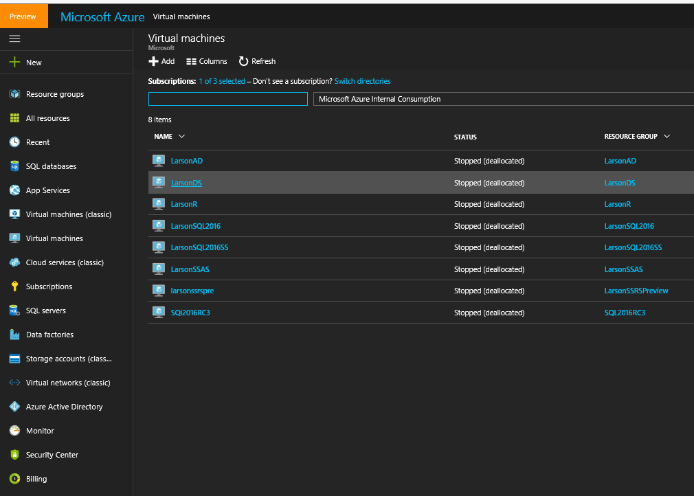
2. Click Connect, When Prompted Click “Open”. This will open a remote desktop session to your Virtual Machine in Azure

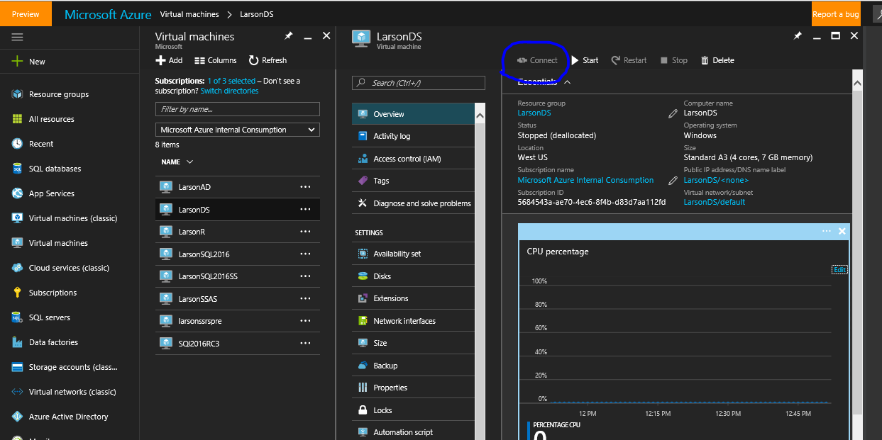

1. We will need to access the internet to download some assets. From Server Manager on your VM, Select IE Enhanced Security Configuration. Toggle Administrators to “Off”

Machine generated alternative text:
Server Manager Local Server 
Dashboard 
i Local Server 
ii All Servers 
File and Storage Services 
PROPERTIES 
For LarsonTempSQL 
Computer name 
Workgrou p 
Windows Firewall 
Remote management 
Remote Desktop 
NIC Teaming 
Ethernet 
Operating system version 
Hardware information 
Larson TempSQL 
WORKGROUP 
Public: On 
Enabled 
Enabled 
Disabled 
IPw4 address assigned by DHCP, IPv6 enabled 
Microsoft Windows Server 2016 Datacenter 
Microsoft Corporation Virtual Machine 
Internet Explorer Enhanced Security Configuration 
Last installed updates 
9/27/2016 9:15 PM 
Windows Update 
Never check for updates 
Last checked for updates 
9/27/2016 9:18 PM 
Windows Defender 
Real-Time Protection: On 
Feedback & Diagnostics 
Settings 
ity Configuration On 
(UTC) Coordinated universal Time 
00376-40000-00000-AA947 (activated) 
Log 
System 
Application 
Application 
Application 
Application 
System 
i cation 
Internet Explorer Enhanced Security Configuraton (IE ESC) reduces the 
exgu)sure of pur server to potential attacks from Web-based content. 
Internet Explorer Enhanced Security Configuration is enabled by 
default for Administrators and Users groups. 
Administr a tors: 
C) On (Recommended) 
@Off 
@On (Recommended) 
C) Off 
More about Internet Explorer Enhanced Security Confiauraton 
11/29/2016 PM 
11/29/2016 PM 
11 2016 PM 
(RAM) 
Intel(R) Xeon(R) CPU E5-2673 v3 @ 2_40GHz 
28 G8 
1433.87 
EVENTS 
All events | 62 total 
Server Name 
LARSONTEMPSQL 
LARSONTEMPSQL 
LARSONTEMPSQL 
LARSONTEMPSQL 
LARSONTEMPSQL 
LARSONTEMPSQL 
LARSONTEMPS L 
ID 
10016 
1534 
55523 
1008 
2004 
10016 
57052 
Severity 
Error 
Warning 
Warning 
Error 
Error 
Error 
Error 
Source 
M icrOSOft-Windows-DistributedCOM 
Microsoft-Windows-User Profile Service 
Microsoft SQL Server Automated Patching 
M icrOSOft-WindOws-PerfIib 
M i crosoft-Windows-PerfNet 
M icrosoft-Windows-DistributedCOM 
Microsoft L Server Automated Backu 

1. From your new Virtual Machine, Navigate to https://github.com/sslarson/titanic

Machine generated alternative text:
O https. 
Back 
github.com 
Page v Safety v 
e LarsonTempSQL 
e GitHu... 
Tools v 
o 
This repository Search 
LJ sslarson / titanic 
Microsof... 
Pull requests 
Y? (99) Yammer . 
• Home 
Issues 
O sslarson/titan 
O Fork 
O Code 
(D Issues o 
Pull requests 
Gist 
Pulse 
@ Unwatch 
I Star 
Graphs •t} Settings 
Projects 
V I branch 
Initial commit 
Added Titanic BAK 
Wiki 
No description or website provided. — Edit 
2 commits 
New pull request 
sslarson committed on GitHub Added Titanic BAK 
@ READMEmd 
Titanic.bak 
EB README.md 
titanic 
O O releases 
Create new file 
I contributor 
LWoad files Find file 
Clone or download • 
Latest commit aea21ge 22 days ago 
22 days ago 
22 days ago 

1. Click on Titanic.bak and Download to the C drive

Machine generated alternative text:
o 
This repository 
Search 
Pull requests 
Issues 
LJ sslarson / titanic 
Gist 
Pulse 
@ Unwatch 
Star 
O Code 
: master 
(D Issues o 
Pull requests O 
Projects 
Wiki 
View Raw 
Graphs 
titanic / Titanic.bak 
•t} Settings 
Download 
Find file 
Fork 
Copy path 
sslarson Added Titanic BAK 
I contributor 
2.92 
aea21ge 22 days ago 
Hist 
(Sorry about that, but we can't show files that are this big right now.) 

1. Click the Start Menu and Type “Management” to bring up Microsoft SQL Management Studio, and login using administrator credentials (it should just connect via Windows Security, since we used an administrator password)  
   Machine generated alternative text:
   Server Manager Dashboard 
   WELCOME TO SERVER MANAGER 
   Dashboard 
   Local Server 
   All Servers 
   File and Storage Services 
   QUICK START 
   HAT'S NEW 
   Best match 
   Print Management 
   Desktop app 
   Computer Management 
   Desktop app 
   Apps 
   Microsoft SQL Server Management Studio 
   Settings 
   Color Management 
   Create and format hard disk partitions 
   Change advanced color management 
   settings for displays, scanners, and printers 
   managementl 
   Configure this local server 
   2 
   3 
   4 
   5 
   oups 
   Add roles and features 
   Add other servers to manage 
   Create a server group 
   Connect this server to cloud services 
   Servers total: I 
   Local Server 
   Manageability 
   Events 
   Services 
   Performance 
   BRA results 
   11/29/2016 4:55 PM 
   ii All Servers 
   @ Manageabilit 
   Events 
   Services 
   Performance 
   BRA results 
2. Right Click on Database and select Restore Database

Machine generated alternative text:
Microsoft SQL Server Management Studio (Administrator) 
Edit View Debug Tools Window Help 
NewQuer,' Y 
Object Explorer 
Connect • 
LARSONTEMPSQL (SQL Server 13.0.4DC 
.40. 
Secu 
Serve 
Repli 
Poly 
Ma 
Integ 
New Database... 
Attach... 
Restore Database... 
Restore Files and Filegroups... 
Deploy Data-tier Application... 
Import Data-tier Application... 
Start PowerSheII 
Reports 
Refresh 

1. Be sure to change the location of the database files to F:\Data and F:\Log   
     
   Machine generated alternative text:
   ueoug 
   Object Explorer 
   VVlnaow 
   New Query 
   Connect • D: 
   LARSONTEMPSQL (SQL server 13.0.40C 
   Databases 
   System Databases 
   Database Snapshots 
   Security 
   Server Objects 
   Replication 
   Poly8ase 
   AlwaysOn High Availability 
   Management 
   Integration Services Catalogs 
   SQL Server Agent (Agent XPs disabl 
   Restore Database - Titanic 
   'O Ready 
   Select a 
   General 
   Files 
   Options 
   LARSONTEMPSQL 
   [LARSONTEMPSQL\Scott] 
   View connection properties 
   Progress 
   fj Locate Database Files - LARSONTEMPSQL 
   Select the file 
   Windows Defender 
   Windows Mail 
   Windows Media Player 
   Windows Multimedia Platform 
   Windows NT 
   Windows Photo Viewer 
   Windows Portable Devices 
   Windows Sidebar 
   WindowsApps 
   WindowsPowerSheII 
   Program Flas 
   Program Data 
   Raco vary 
   D SQLIaaS&tension 
   SQLServar 130 Full 
   System Volume Homation 
   Windows 
   WindowsAzura 
   Ttanicbak 
   SRECYCLE BIN 
   Restore As 
   Files\ 
   Files\ 
   Log 
   Selected path 
   Files of type 
   File name 
   F: Oat a 
   Al F,leso 
   Ttanic.mdfl 

Machine generated alternative text:
Restore database files as 
Relocate all files to folder 
Data file folder : 
Log file folder : 
oft SQL ServerWSSQL13. 
SQL Server\MSSQL 
F: \Data 
Restore As 

## Create a new SQL Azure Database (Platform As a Service)

1. Select SQL Databases from the left menu and Click Add  
   Microsoft Azur 
   Resource groups 
   All resources 
   Recent 
   SQL databases 
   App Services 
   Virtual machines (classic) 
   Virtual machines 
   Cloud services (classic) 
   Subscriptions 
   SQL servers 
   Data factories 
   Storage accounts (class.„ 
   Virtual networks (classic) 
   Azure Active Directory 
   Monitor 
   Add 
   uaLa 
   + Add 
   es 
   Columns Refresh 
   I of 3 selected — Don't see a subscription? Switch &rectories 
   Filter name. 
   12 items 
   Lahman2015 
   TitaNc 
   Lahman2015 
   MyTestDatabase 
   ChicagoCnrne2014 
   LahmanBasebaII 
   Losß.ngeIesOpenData 
   Solano County Health 
   Microsoft Azure Internal Consumption 
   STATUS 
   Online 
   Online 
   Online 
   Online 
   Online 
   Online 
   Online 
   Online 
   Online 
   Online 
   Online 
   Online 
2. Name the Database, Use Existing Resource Group, Select Sample Database (Adventure Works V12)
3. Microsoft Azure 
   SQL databases > 
   SQL Database 
   Server 
   Server 
   Create a new server 
   larsonsqlpaas 
   la rsonsqlpaaseast 
   East US 
   q4dku2ggv8 
   x 
   (0) 
   Resource groups 
   All resources 
   Recent 
   SQL databases 
   App Services 
   Virtual machines (classic) 
   Virtual machines 
   Cloud services (classic) 
   Subscriptions 
   SQL servers 
   Data factories 
   Storage accounts (class.„ 
   Virtual networks (classic) 
   Azure Active Directory 
   Monitor 
   Security Center 
   SQL Database 
   Database n arne 
   LarsonTempSQL 
   ubscription 
   %rosM .Azure Intemal 
   Resource gulp 
   Create new Use existin g 
   LarsonTe 
   Select source 
   Sarnple 
   Sdect san-we 
   AdventureWorksLT MI 2] 
   Configure required settings 
   Want to use SQL elastic 
   Yes O Not now 
   tie 
   S2 Standard 
   Collation 
   Specified by sample 
   Defaul... 
   Defaul... 
   Defaul... 
4. Select Server, and Select “Create a new Server”

Note: This isn’t a “Server” like a Virtual Machine is. This is just a logical representation for management purposes.  
Microsoft Azure 
SQL databases > 
SQL Database 
Server 
New server 
Server 
Create a new server 
larsonsqlpaas 
la rsonsqlpaaseast 
q4dku2ggv8 
X 
(0) 
Resource groups 
All resources 
Recent 
SQL databases 
App Services 
Virtual machines (classic) 
Virtual machines 
Cloud services (classic) 
Subscriptions 
SQL servers 
Data factories 
Storage accounts (class.„ 
Virtual networks (classic) 
Azure Active Directory 
Monitor 
Security Center 
SQL Database 
Database n arne 
LarsonTempSQL 
ubscription 
%rosM .Azure Intemal 
Resource gulp 
Create new Use existin g 
LarsonTe 
Select source 
Sarnple 
Sdect sanple 
AdventureWorksLT MI 2] 
Configure required settings 
Want to use SQL elastic 
Yes O Not now 
tie 
S2 Standard 
Collation 
Specified by sample 
Defaul... 
Defaul... 
Defaul... 
New server 
Server n anne 
I arsonsqttemp 
r login 
rm password 
.database.wi n dows net 
Create VI 2 server (Latest update) 
Y] Allow azwe services to accæs server 

1. Select Pricing Tier, explore some of the ranges and features, Click Create

Microsoft Azure 
SQL databases > 
SQL Database 
Choose your pricing 
Choose your pricing 
SQL Database 
Database n arne 
LarsonTempSQL 
ubscription 
%rosM .Azure Intemal 
Resource gulp 
Create new Use existin g 
LarsonTe 
Select source 
Sarnple 
Sdect sanple 
AdventureWorksLT MI 2] 
larsonsqltemp (West US) 
Want to use SQL elastic 
Yes O Not now 
tie 
S2 Standard 
Collation 
Specified by sample 
to 
Automation options 
and witin æch ærvice 
uniG (DTI's) Q*city of 
(0) 
Resource groups 
All resources 
Recent 
SQL databases 
App Services 
Virtual machines (classic) 
Virtual machines 
Cloud services (classic) 
Subscriptions 
SQL servers 
Data factories 
Storage accounts (class.„ 
Virtual networks (classic) 
Azure Active Directory 
Monitor 
Security Center 
Billing 
Help + support 
More services 
Point In Tink Restore... 
3,720.00 
uso,'VONTH ESTIMATED 31 
Sta n d 
Geo-Replication 
Point In Time Restwe... 
Auditing 
7,000.11 
uso,'MCNTH 
I Stand 
Point In Tink Restore... 
15,999.97 
uson.'0NTH (ESTIMATED 31 PIE 
S2 Stand 
10 
DTUs 
up to 250 
Point In Tink Restore... 
15.00 
20 
DTUs 
up to 250 
Geo-Replication 
Point In Time Restwe... 
Auditing 
30.00 
50 
DTUs 
up to 250 
Point In Tink Restore... 
75.02 
uso,'VONTH ESTIMATED 31 SO 
uso,'MCNTH (ESTIMATED Sl 
so,'VONTH ESTIMATED 31 sa 
100 
DTUs 
up to 250 
Point In Tink Restore... 
Available uüy fw latem 
5 
DTUs 
up to 263 
Geo-Replication 
Point In Time Restwe... 
Auditing 

# [SLIDES – SQL Azure Service Levels, DTU)

Brief Tour of SQL Azure Database Settings  
1. Select SQL Databases from the left menu, Select your database, Select Overview

You will use “Server Name” to connect from SQL Management Studio in a later step

port a 
Restore 
(0) 
Microsoft Azure 
SQL databases 
SQL databases 
+ Add 
Columns 
Refresh 
I of 3 selected — see a 
subscriptim? 9.'Jitch directories 
filter by namem 
Microsoft Azure Internal Consumption 
13 items 
NAME v 
LosAngeIesCrim e 
Titanic 
MyTestDatabase 
ChicagoCrime2014 
Lahman3asebaII 
LosAngeIesCrim e 
LosAngeIesOEk•n Data 
Solano Health 
La rson Tem pSQL 
LarsonTempSQL 
SQL data 
Search (CM+D 
Activity 
Tags 
solve problerns 
Quick start 
Pricing tier (scale DTUs) 
Geo-Replicati&l 
Auditing & Threat detection 
Dynamic data masking 
Transparent data encyption 
P ropertiæ 
a Locks 
Automation script 
Alert rules 
Database size 
p 
Search resc 
Tools Copy 
Essenbals 
LarsonTempRG 
Online 
west US 
Export 
O Set server firew... 
larsonsq Itemp.database.windowsnet 
stri ngs 
Show database connection strings 
S2 standard (50 DTus) 
role 
Not configured 
Microsoft Azure Internal Consumption 
10 
5684543a-ae70-4ec6-8f4b-d83d7aa112fd 
Monitoring 
Resource utilization 
Performance 

1. Click “Show database connection strings”

Machine generated alternative text:
Microsoft Azure 
SQL databases 
SQL databases 
Refresh 
(0) 
Larson TempSQL > Database connection strings 
LarsonTempSQL 
SQL data 
Search (CM+D 
Activity 
Tags 
solve problerns 
Quick start 
Pricing tier (scale DTUs) 
Geo-Replicati&l 
Auditing & Threat detection 
Dynamic data masking 
Transparent data encyption 
P ropertiæ 
a Locks 
Automaton script 
Alert rules 
Search rescwrces 
Database connection strings 
x 
+ Add 
Columns 
I of 3 selected — see a 
Tools Copy 
Essenbals 
LarsonTempRG 
Online 
west US 
Restore 
Export 
Set server firew... 
subscriptim? 9.'Jitch directories 
filter by namem 
Microsoft Azure Internal Consumption 
13 items 
LosAngeIesCrim e 
Titanic 
MyTestDatabase 
ChicagoCrime2014 
Lahman3asebaII 
LosAngeIesCrim e 
LosAngeIesOEk•n Data 
Solano Health 
ADO.NET 
JD3C 
ODBC 
larsonsq Itemp.database.windowsnet 
stri ngs 
Show database connection strings 
S2 standard (50 DTus) 
role 
Not configured 
Microsoft Azure Internal Consumption 
10 
5684543a-ae70-4ec6-8f4b-d83d7aa112fd 
Monitoring 
Resource utilization 
li.41% 
ADO.NET (SQL authentication) 
& tep • . databa 
r_pa s rd} ; t p 
ADO.NET driver for SQL server 

1. Connect to your SQL Azure Database from SQL Management Studio

If your desktop has SQL Management Studio, use that. If not, use SQL Management Studio on the Virtual Machine you created

Hover over the Server Name and click on the right icon to copy.

Machine generated alternative text:
Tools Copy 
Essenbals 
group 
LarsonTempRG 
Online 
west US 
Restore 
Export 
O Set server firew... 
Microsoft Azure Internal Consumption 
10 
5684543a-ae70-4ec6-8f4b-d83d7aa112fd 
Monitoring 
Crick to copy 
larsonsq Itemp.database.windowsnet 
stri ngs 
Show database connection strings 
S2 standard (50 DTus) 
role 
Not configured 

1. Paste into SQL Management Studio connection dialog

Machine generated alternative text:
Connect to Server 
Server type 
Server name: 
Authentication. 
Login: 
Password. 
x 
SQL Server 
Database Engina 
larzonsqltamp .database windowsnat 
SQL Server Authentication 
[3 Ramamber password 
Connect 

If you connected from your desktop you will probably get a firewall message. This is because, by default SQL Azure Database only allows access from resources within Azure.

If you connected from a VM you will not get this message, since that VM is in your Azure environment.

Machine generated alternative text:
Conne 
New Firewall Rule 
x 
Server na 
Authenti 
Login: 
pa 
Your cliant IP address does not have access to tha server. Sign in to 
an Azura account and create a nawfirawall n-Jle to anable access. 
Azura account 
You ara not signad in to Microsoft Azure 
Sign ln. 
firewall rule 
my client 1108.225.58.175} 
Add my subnet IP range 
From 108.225.56.0 
To 108.225.56.255 
Cancel 
•ons 

Note your Client I.P.

1. From your SQL Azure Database, select “Set Server Firewall”

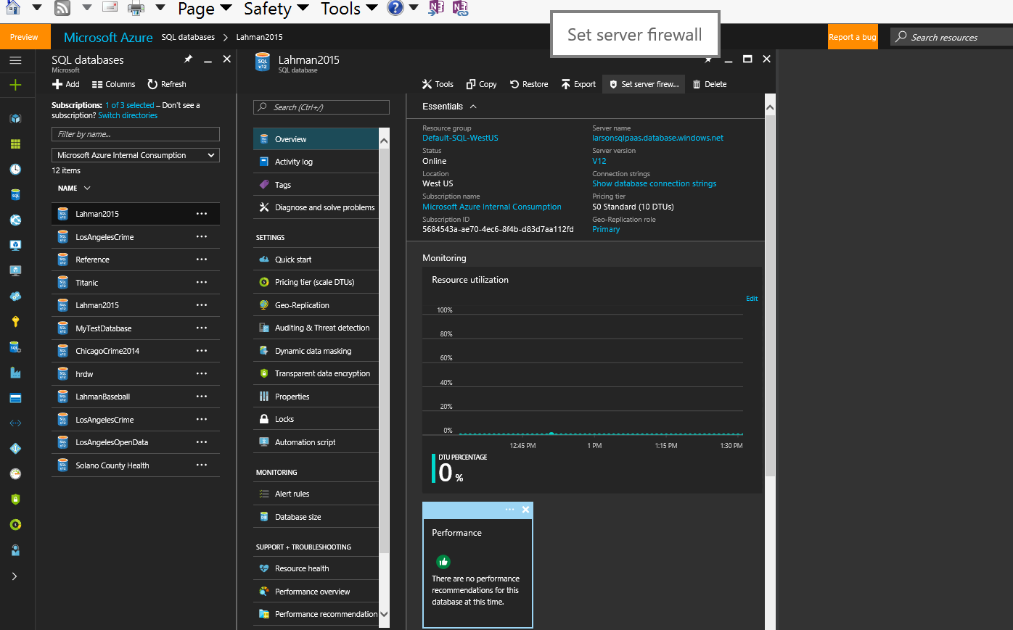

1. Type in your Client IP (as shown in the SSMS firewall error dialog). Name the Rule
2. Click Save

Machine generated alternative text:
larsonsqltemp - Firewall 
Search (Ctrl*" 
Activity log 
Access ccntrol 0.4M) 
Tags 
X Diagnose and solve problems 
Firewall 
Lorvterm backup retention 
& Threat detection 
Save 
+ dient IP 
X Discard 
Connections from Ps belcw prwides access to all the databases in 
I arsonsqltemp. 
Allcnv access to Azure services 
Chent IP addræs 
108225.56175 
START 
108255.56175 
108255.56175 

1. Compare Properties of SQL in a VM vs. SQL Azure
2. In SSMS connected to the SQL Instance created when you created the Virtual Machine, Right Click on a database and browse the properties

Machine generated alternative text:
d 
Server Properties 
Select a 
G an aral 
Memory 
Security 
Connections 
Database Settings 
Advanced 
LARSONTEMPSQL 
Scnpt Help 
DefauH index fill factor 
Backup and restore 
Specfy ho',v long SQL Server Rill natt for a ne',v tapa 
Watt indafinttaly 
@ Try once 
Try for 
DefauH backup media retention On days) 
minute(s) 

1. Do the same from SSMS connected to the SQL Azure database

Machine generated alternative text:
Database Properties - LarsonTempSQL 
Select a 
Script 
Ganaral 
Options 
Change Tracking 
Pamissions 
Quay Store 
x 
Halp 
[Habase 
Name 
Status 
Owner 
Date Creatad 
Size 
Space Available 
Number of users 
Mairtenance 
Collation 
Normal 
Scott 
I l/2S/2016 PM 
258000.00 MB 
MB 
4 

# Optional: Connect to SQL Azure From Power BI Desktop

# Deploying an existing database to SQL Azure Database

1. From SQL Management Studio in your Virtual Machine, connect to the SQL Instance that was created with the VM.
2. Right click on the Titanic Database (the one you restored earlier), Select “Deploy Database to Microsoft Azure SQL Database”

Execute Debug 
Object Explorer 
Connect • 
LARSONTEMPSQL (SQL server 130.4001.0- LARSONTEMPSQL\Scott) 
D Databases 
System Databases 
Database Snapshots 
SQLQueryI .sql 
—SELECT 
Script for Select TopURows command from SSMS 
TOP Iøøø [Passengerld) 
, [Sut•.'ived) 
, CPcIass) 
, [Name) 
, [Sex) 
, [Age) 
, CSibSp) 
, [Parch) 
, [Ticket) 
, [Fare) 
itanic) 
Secui 
Server 
Repli 
Poly 
New Database... 
New Query 
Script Database as 
Tasks 
Policies 
Facets 
Start PowerSheII 
Reports 
Rename 
Delete 
Refresh 
Properties 
Detach... 
Take Offline 
Bring Online 
Stretch 
Encrypt Columns... 
Shrink 
Back Up... 
Restore 
Mirror... 
AlwaysOn High Availability 
Management 
Integration Services Catalogs 
SQL Server Agent (Agent XPs disabled) 
larsonsqltemp.database.windows.net (SQL Server 12.0 
Launch Database Mirroring Monitor... 
Ship Transaction Logs.. 
Generate Scripts... 
Generate In-Memory OLTP Migration Checklists 
Extract Data-tier Application... 
Deploy Database to Microsoft Azure SQL Database... 
Deploy Database to a Microsoft Azure VM... 
Export Data-tier Application... 
Register as Data-tier Application... 
Upgrade Data-tier Application... 
Delete Data-tier Application... 
Import Data... 
Export Data... 
Copy Database... 
Manage Database Encryption... 
8raund Mr Owen Hams 
Cumngs. MB John Bradley (Florence 8nggs Thay 
Haikkjnan. Miss Laina 
Futrelle. MB Jacques Heath (Lib' May Peel) 
Alan Mr William Henry 
Moran Mr James 
McCarthy Mr Timothy J 
Palsson. Master Gosta Leonard 
Johnson MB Oscar W (Eisabeth Vilhalmina Berg) 
Nasser. MB Nicholas (Adele Achem) 
Sandstrom. Miss Marguerite Rut 
80nneII Miss Elizabeth 
Saurdercock. Mr William Henry 
Andersson Mr Anders Johan 
Vestrom. Miss Hulda Amanda Adotfina 

1. At the dialog, click Connect and type in your credentials to the SQL Azure Server created earlier, click finish

Object Explorer 
Connect • 
LARSONTEMPSQL (SQL server 13.04001.0 
O [Z Databases 
System Databases 
D Database Snapshots 
Titanic 
D Database Diagrams 
Tables 
System Tables 
FileTabIes 
External Tables 
dbo.Titanic 
Views 
External Resources 
Synonyms 
Programmability 
Service Broker 
D Storage 
Security 
Security 
Server Objects 
Replication 
Poly8ase 
AlwaysOn High Availability 
Management 
Integration Services Catalogs 
SQL Server Agent (Agent XPs disabled) 
LARSONTEMPSQL\Scott) 
SQLQueryI .sql 
—SELECT 
F ROM 
Script for SelectTcpNRows command 
TOP Iøøø [Passengerld) 
, [Sut•.'ived) 
f rom 
ssms 
, [PCI 
, [Sex) 
, [Age) 
, [Sib 
c Tic 
, CFar 
, [Cab 
, (Emb 
Deploy Database 'Titanic' 
Deployment Settings 
Introduction 
Deployment Settings 
Summary 
Results 
Connect to Server 
Sarver type 
Server name 
SQL Server 
Database Engine 
larsonsqttamp database windows.nat 
SQL Server Authentication 
Remember password 
Passen garld 
larsonsqltemp.database.windows.net (SQL Server 12.0.2DDO.8 
- Scott) 
Service Objective 
Other settings 
Temporary file name: 
Help 
Database server 
k Connect to login 
Connect... 
Browse... Machine generated alternative text:
L Hassenger 
, [Sut•.'ived) 
, [PCI 
column Pclass(smallint, null) 
, [Age) 
, [Sib 
c Tic 
, CFar 
, [Cab 
, (Emb 
FROM [Tit 
Passen gerld 
Summary 
Introduction 
Deployment Settings 
Summary 
Results 
Help 
Verify Specified Settings 
To complete the operation using the specfied settings, click Finish. 
Source 
Name: LARSONTEMPSQL 
Connected as: LARSONTEMPSQL\Scott 
Database: Titanic 
Source Database Size: 16.0 MB (Note that the deployed database might be larger than 
[4 Target 
Name: larsonsqltemp 
Connected as: Scott 
Database: Titanic 
Edition: Basic 
Maximum Database Size: 2 G8 
Service Objective: Basic 
Environment 
Temporary File Location: 
Size available for temporary file: 98.8 G8 
Previous 
Finish 
Cancel 

# Manually scaling Virtual Machines and SQL Azure Databases

1. Virtual Machine: Select your virtual machine, Select Size, and choose a new size. It will scale on the fly.

Machine generated alternative text:
v page v 
Virtual machines > 
Safety v Tools v 
LarsonTempSQL > Choose a size 
Home (Alt+M) 
56 6B 
Reportabug 
p Search resources 
LarsonT... 
Search (CM+D 
Availability set 
Network interfacæ 
Backup 
SQ_ Server configuration 
P ropertiæ 
a Locks 
Automation script 
SCHEDULES 
Alert rulæ 
settings 
X 
Choose a size 
Prices presented are estimates in ya_jr local curreng that include only Azure infrastructure costs and 
any discounts for the subscription and location. The prices indude any software 
Notifications 
scottlar@microsoft.co... 
ismiss al 
(0) 
Virtual machines 
+ Add 
Columns C.) Refresh 
I of 3 selected — see a 
subscriptim? 9.'Jitch directories 
filter by namem 
Microsoft Azure Internal Consumption 
9 items 
LarsonSCU016 
LarsonSCU016SS 
LarsonTempSQ_ 
SQ2016RC3 
Resizing virtual machine Runnirg 
Resizing virtual machine • LarsonTempSQL' to size ' Standard 
updated server firewall rul.„ 9:55 
Successfully updated firewall rules for server. larsonsqlternp 
Successfully updated server firewall rul.„ 9:54 
Successfully updated firewall rules for server. larsonsqlternp 
3.5 
8 
28 
Data disks 
sso 
98.95 
usDNONTH (ESTIMATED) 
Chta disks 
Max lops 
sso 
2 
7 
16 
Core 
MM ops 
100 
ssD 
Load balancing 
197.90 
uso,'MCNTH 
Cores 
lops 
800 
ssD 
Load balancing 
4 
14 
2 
14 
Chta disks 
Max lops 
sso 
395.06 
usDNONTH (ESTIMATED) 
63 
Chta disks 
4x5m 
Max lops 
sso   
  
2. SQL Azure: Select your SQL Database, Select Pricing Tier, click Select.

Machine generated alternative text:
X 
(0) 
databases 
Columns 
Refresh 
I of 3 selected — see a 
jscriptim? 9.'Jitch directories 
"Iter by name 
licroson Azure Internal Consumption 
items 
LosAngeIesCrim e 
Titanic 
MyTestDatabase 
Titanic 
ChicagoCrime2014 
Lahman3asebaII 
LosAngeIesCrim e 
LosAngeIesOEk•n Data 
Solano Health 
LarsonT... 
SQL data 
Search (CM+D 
Activity 
Tags 
solve problerns 
Quick start 
Pricing tier (scale DTUs) 
Geo-Replicati&l 
Auditing & Threat detection 
Dynamic data masking 
Transparent data encyption 
P ropertiæ 
a Locks 
Automation script 
Alert rules 
Database size 
suppcRT + TRCRJBLESHCOTING 
Resource health 
Perfumance met-view 
Perfumance recommendabon 
Change your pricing 
up a 
ce witin 
3,720.00 
uso,voNTH ESTIMATED 31 PO 
SO Stand 
7,000.11 
I Standar 
15,999.97 
uso,voNTH ESTIMATED 31 
Standa 
10 
DTUs 
up to 250 
Geo - Rea ication 
Point In Tink Restore... 
15.00 
20 
5 
DTUs 
up to 250 G 
Replication 
Point In Time Restorem 
Auditing 
30.00 
DTUs 
up to 263 
Replication 
Point In Time Restorem 
Auditing 
4.99 
50 
DTUs 
up to 250 
Geo - Rea ication 
Point In Tink Restore... 
75.02 
usDNONTH ESTIMATED 31 
S3 Standard 
usDNONTH ESTIMATED 31 sa 
100 
DTUs 
up to 250 
Geo - Rea ication 
Point In Tink Restore... 
Avilable only for latem 
150.00 
usDNONTH ESTIMATED 31 S3 

# Deleting everything we just created

1. From left menu, select “Resource Groups”, select your resource group, select Delete. You must type in the resource group name to confirm. You can NOT undo deleting a resource group.

Machine generated alternative text:
Microsoft Azure 
Resource groups 
ion'tsee a 
(0) 
Resource groups 
All resources 
Recent 
SQL databases 
App Services 
Virtual machines (classic) 
Virtual machines 
Cloud services (classic) 
Subscriptions 
SQL servers 
Data factories 
Storage accounts (class.„ 
Virtual networks (classic) 
Azure Active Directory 
Monitor 
Security Center 
Billing 
Help + support 
More services 
> Larson TempRG 
> Are you sure you want to delete "LarsonTempRG" . 
LarsonTempRG 
port a 
Search rescwrces 
x 
Noti 
+ Add 
Essentials 
C&umns 
Delete 
Refresh 
Move 
p Search CM D 
0 
Activib' log 
Access control (I AM) 
Tags 
SETTI'GS 
u ickstart 
Deploym ents 
Properties 
Locks 
Automation script 
MCNTCRING 
Alert rules 
logs 
Application insights 
Log analytics (OMS) 
Log search 
suppcRT TROUBLESHOOTI% 
New support request 
Microsoft Azure Internal Consumption 
2 Succeeded 
Filter name. 
12 items 
I arsmsqltemp 
LarsonTempSQL 
TitaNc 
I arsontemprgdiag411 
I arsontemprgd isks164 
LarsonTempRG 
LarsonTempSQL 
aasExtension 
I arsontempsq1743 
LarsonTempSQL- ip 
LarsonTempSQL-nsg 
s hutdown-conv utevm - LarsonTempS• 
5684543a-ae70-4ec6-8f4b-d83d7aa 1 1 2fd 
west US 
SQ_ database 
SQ_ database 
Storage account 
Storage account 
Virtual netv.ork 
Virtual machine 
Microsoft. Co m pute„. 
Network interface 
Public IP 
Network security gr... 
Microsoft. k'TestL„ . 
Are you sure you want to delete "LarsonTempRG"? 
Waming! Deleting the •LarsonTempRG" resource group is irreversible. The action you •re 
about to take cant undone. further Will delete this resource group and all the 
resources in it permanently. 
TYPE THE RESOURCE GROUP NAME. 
LarsonTem pRG4 
Affected resources 
There are 12 resources in this group that be deleted. 
west US 
west US 
west US 
west US 
LarsonTempSQL 
Sq' la as Extension 
sh utdown-computevm - LarsonTernpS( 
I arsontempsq1743 
La rsonTem pSQI— nsg 
La rsonTem ip 
La rsonTemøRG-vnet 
I arsonsqltemp 
LarsonTempSQL 
larsontemprgdiag411 
larsontemprgdisks 164 
VI 2.0,user 
VI 2.0,user 
Virtual machi„. 
Microsoft. De.. 
Network inte... 
Network sec... 
Public IP add.„ 
Virtual netw... 
SQL database 
SQL database 
Storage acco. 
Storage acco. 